***Virtual Personal Assistant App***

*Specialized for Students*

*Priyanshi Jaiswal*

Department of CS: Computer Engineering

ABES Engineering College (APJAKTU)

Ghaziabad, U.P., India

[priyanshi.19b151053@abes.ac.in](mailto:priyanshi.19b151053@abes.ac.in)

*Neha Varshney*

Department of CS: Computer Engineering

ABES Engineering College (APJAKTU)

Ghaziabad, U.P., India

[neha.19b151058@abes.ac.in](mailto:neha.19b151058@abes.ac.in)

*Ananya Raman*

Department of CS: Computer Engineering

ABES Engineering College (APJAKTU)

Ghaziabad, U.P., India

[ananya.19b151055@abes.ac.in](mailto:ananya.19b151055@abes.ac.in)

*Mrs. Poonam Rana*

Department of Computer Science

ABES Engineering College (APJAKTU)

Ghaziabad, U.P., India

[poonam.rana@abes.ac.in](mailto:poonam.rana@abes.ac.in)

***Abstract***- **A Virtual Personal Assistant app is an epitome of software Assistant that gets your tasks and services done by comprehending user’s command whether it is through text or voice recognition. The virtual assistant uses Natural language processing (NLP) to comprehend text provided by user or user input through voice to get user’s tasks done by executing it. They are additionally consistently utilizing Artificial Intelligence procedures including Machine learning. The virtual personal assistant apps are specifically operated through online chatting are often termed as Chabot.**

**A shrewd virtual personal assistant is an energized operator with social knowledge that has been created for a specific client populace. The knowledge of a VPA is decided by the capacity of the specialist to be engaging, full of feeling, versatile, easy to use and important while communicating with the client.**

**Virtual assistant is a blessing for everyone in this new era of technology and has attracted almost the whole world. It has made a way for the new technology from which we can interact with the virtual assistant apps/devices as we interact with humans. Portions of the popular virtual assistant’s are Siri by apple, Cortana by Microsoft, Google assistant and Alexa by Amazon.**

**However, there are several virtual personal assistant apps which can do numerous tasks but we still couldn’t find any VPA app that would help the torch bearers of our future i.e. our students wholly and that’s why we came in the picture. A virtual personal assistant app was needed which could help the students in their studies as well as it could help them in their daily lives and could act according to their needs and requirements. So here we are, introducing a virtual assistant app that is specialized for students but it can also be very advantageous for other people also.**

Keywords- Virtual Personal Assistant, Chatbot, Natural Language Processing, Voice recognition, Artificial Intelligence, Machine Learning.

# Introduction

A virtual personal assistant likewise called as AI assistant or Digital assistant is an application program that comprehends regular human language, interacts in characteristic language, and finishes electronic undertakings for the user.

A few tasks performed by a personal assistant are taking transcription, understanding content or email messages permitted, looking into contact numbers, booking, putting calls and reminding the client about arrangements. Some of the time the expression "Chabot" is utilized to allude to virtual assistants and large or explicitly got to by online chat.

In 2011, the first virtual personal assistant came named 'Siri' in Apple iPhone 4s. Well known virtual assistant includes Alexa by Amazon, Siri by Apple, Google assistant and Microsoft’s Cortana. Every one of these applications is normally cloud based projects that require internet associated devices (gadgets) or possibly applications to work. The Technologies that power VPA(s) required monstrous measures of data, which takes care of AI stages, including ML, Natural language processing (NLP) and voice recognition stage. As the client associates with the VPA, the AI programming utilizes advanced calculations to gain from information enter and turn out to be better at foreseeing the user’s need. Some virtual personal assistant gadgets such as Amazon Echo, Apple homepod, Google home all these devices are also voice- enabled and perform same functions as VPA applications perform but these devices are very costly. So, Instead of using these devices people use virtual personal assistant applications.

Latest virtual personal assistant app is Samsung Bixby which works same as other apps such as Siri or Alexa which is ideally suited for Samsung devices.

So what should one expect from the smart assistant?

1- The ability to comprehend natural language and get familiar with your dialect.

2- The ability to adjust to your way of life and prerequisites.

3- The ability to amplify the cell phone's capabilities.

# ADVANCEMENTS UTILIZED IN VPA APPLICATIONS

1. *Voice/speech to text(STT)* –

It is an assistive technology (AT) instrument that can help students who battle with composing. You may hear it referred to as "speech-to-text," "voice-to-text," "voice recognition" or "speech recognition" innovation. Students will be able to utilize dictation to compose with their voices, rather than composing by typing with the help of a keyboard. This can be advantageous for students and other learning and thinking contrasts that effect composing.

1. *Text to speech (TTS) –*

Text to speech, that is also called TTS, is a kind of speech synthesis that changes text into spoken voice yield. The first time text to speech frameworks were evolved with the goal to help the visually impaired by providing a PC produced spoken voice that would "read" text to the client. TTS permits your gadget to dictate aloud to you from the digital text. TTS is ideal for supporting the individuals who battle with reading or for naming explicit things on a screen. It is regularly utilized for developing readers or students that need additional help, yet is generally accessible and upheld on gadgets around the globe.

1. *Intelligent tagging and decision making* –

Intelligent Tagging utilizes natural language processing, text analytics and data mining innovations to get importance from tremendous measures of unstructured content. It's the quickest, simplest and most exact approach to label the individuals, spots, realities and occasions in your information, and afterward appoint money related points and topics to build your content's worth, availability and interoperability.

Associating your data reliably with Intelligent Tagging causes you to look through smarter, customize content proposal.

Decision making- AI is being utilized in decision making for assignments, such as supporting the decision maker to choose activities progressively and distressing choice issues; diminishing data overload, empowering up-to-date data, and giving a dynamic reaction smart operators; empowering correspondence required for community choices; and managing vulnerability in decision problems.

1. *Image Recognition –*

Image Recognition implies changing over a picture into an advanced structure and playing out specific operations on it. Subsequently, it is conceivable to extract some data from such a picture .Sometimes it is likewise called image classification, and it is applied in an ever increasing number of industries.

1. *Noise Control –*

As more individuals keep on working from their homes, tech companies are assisting with work and school productivity by reducing audio distractions utilizing artificial intelligence. They are utilizing AI technology to control background noises during classes or meetings for more proficient interaction and focus. Utilizing this technology will make VPA(s) more reliable and proficient.

1. *Voice Biometrics –*

VPA can utilize voice biometrics to affirm identity of a caller as a component of self-administration communications or before steering the caller to a customer service executive. Associations Intelligent Virtual Assistant (IVA) voice biometrics can uphold both passive and active confirmation. Active confirmation utilizing voice biometrics coordinates a caller's special voiceprint to a passphrase that is produced at the time when the call happened. Passive confirmation utilizing voice biometrics coordinates the voiceprint as the caller talks normally and no exceptional expression or password is needed. Connecting voice biometrics is profoundly exact, requiring only a few seconds to select customer and confirm caller and consistently adjusts to your customer's biometric signature.

1. *Speech Compression –*

It is defined as any procedure to compress speech so as to utilize less transmission capacity when sending or we can say Speech pressure is a key innovation fundamental advanced cell communications, VoIP, voice message, and voice response frameworks. We follow the advancement of speech coding dependent on the linear prediction model, feature the key achievements in speech coding, and layout the structures of the most significant speech coding guidelines. Current challenges, future exploration directions, basic limits on performance, and the basic open issue of speech coding for emergency specialists on call are completely examined.

# Techniques

Some techniques to implement a virtual personal assistant App. Mentioned underneath are some significant techniques which are needed to make a virtual personal assistant. These are the fundamental structure squares of VPA.

1*. Artificial intelligence (AI)*:

For the improvement of VPA we require a lot of information on which AI works by consolidating a lot of information with quick, iterative processing and shrewd calculations, allowing the item to pick up normally from examples or features in the data.

2. *Speech recognition*:

Speech recognition is a significant component utilized in Virtual Personal Assistant. The fundamental capacity of this library is it attempts to comprehend whatever the people talk and convert the speech to text.

3*. Natural language processing (NLP):*

Virtual personal assistants use Natural Language Processing (NLP) to arrange customer’s input in the form of text or voice to executable requests. Many constantly get the hang of utilizing artificial intelligence procedures including Machine Learning.

4. *Machine learning (ML):*

Virtual Personal Assistant needs to get to know the information or solicitation that was once given to review consequently Machine Learning is required. Machine Learning is the utilization of Artificial Intelligence (AI) that empowers frameworks to in this way take in and improves for a reality without being unequivocally adjusted. Machine Learning rotates around the PC program development that can get to information and use it to find perform tasks.

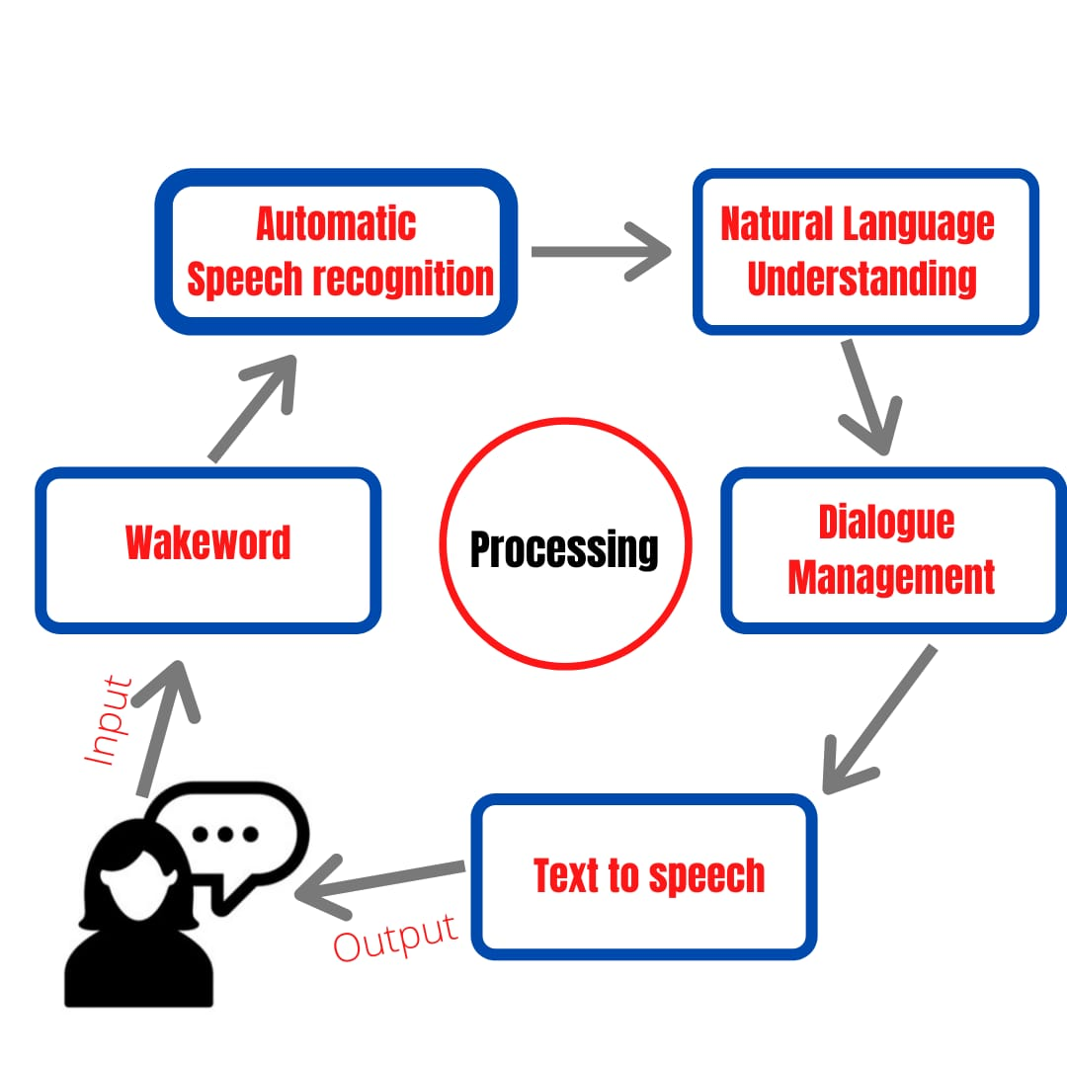

Figure 1. Processing of data from user.

# Literature review

Some popular Virtual Assistant-

* ***SIRI***

Siri is a remote helper that is utilized as partner in Apple iOS, iPadOS, watchOS, macOS, and tvOS working frameworks. Siri is fueled by man-made brainpower i.e. Artificial Intelligence (AI). It utilizes voice inquiries, focus-tracking, motion based control and a Natural Language UI to react to questions, make recommendations, and perform activities by assigning entreats to a bunch of web administrations. Siri upholds a huge extent of customer orders, including performing phone exercises, checking key information, booking capacities and updates, managing the contraption settings, glancing through the Internet, investigating zones, finding information on redirection, and can attract with iOS-composed applications. Siri is a side task from an endeavor from the start made by the SRI International Artificial Intelligence Center. Its talk affirmation engine was provided by Nuance Communications. It was helped to establish by Dag Kittlaus, Tom Gruber, and UCLA former student Adam Cheyer. The first British male voice was given by Jon Briggs. The first Australian voice was given by Karen Jacobsen.

* ***GOOGLE ASSISTANT***

Google Assistant depends on Artificial intelligence (AI) technology, for example, Natural Language Processing (NLP) and AI to comprehend what the client is stating and to make proposals or follow up on that language input Google Assistant can partake in two-way conversations. It at first showed up in May 2016 as a segment of Google's educating application Allo, and its voice-incited speaker that is Google Home. Customers basically partner with the Google Assistant through

-tracking, gesture control and a Natural Language UI to react to questions, give suggestions, and perform activities by assigning entreats to lot of web administrations. Google Assistant depends on Artificial intelligence (AI) technology, for example, Natural Language Processing (NLP) and AI to comprehend what the client is stating and to make proposals or follow up on that language input. Google Assistant can take part in two-manner discussions. Cortana is a virtual personal assistant which utilizes the Bing web index for performing tasks. It normal voice. In a comparative nature and path as Google Now, the Assistant can glance through the Internet, plan capacities and alerts, change gear settings on the customer's device, and indicate information from the customer's Google account. On 11octoberv 2019, Google Assistant released utilizing the voice of Kiki Baessell for the American women's voice. Google released that Issa Rae Google Assistant as a new discretionary voice which can switched by the client by saying "okay, Google, talk like Issa".

* ***CORTANA***

Cortana is a virtual personal assistant created by the Microsoft, which utilizes the Bing web index to complete assignments, for example, setting updates, addressing inquiries for the client. Languages like English, French, Portuguese German, Italian, Spanish, Chinese, and Japanese can be understood by Cortana. It also depends upon the platform and area in which it is utilized. It has been dispatched as a vital component of Microsoft’s arranged “makeover” of things to come working frameworks for Windows and Windows Phone. Cortana can set updates, perceive characteristic voice without the need for support information, and answer addresses utilizing data from the Bing internet searcher (e.g., Climate reports and traffic situations in an area, sports scores, etc.).

* ***AMAZON ALEXA***

Amazon Alexa is a virtual personal assistant which works AI technology produced by Amazon, Amazon Echo was firstly introduced. Customized speech affirmation (ASR) is a development that changes over verbally imparted words into text. Thusly, it's the hidden stage in empowering voice movement With ASR voice development can perceive spoken sounds and recall them as words. It can be used for voice joint exertion, playing music, management, streaming webcasts, book records playback, weather forecast, traffic, sports and it can control two or three gadgets utilizing itself as a home computerization framework.

* ***BIXBY***

Samsung Electronics produced their own virtual personal assistant Bixby. On 20 March 2017, Samsung proclaimed the voice-energized modernized right hand named "Bixby". Bixby is created utilizing artificial intelligence (AI) innovation. At the time of release of galaxy S8 and S8+ model of Samsung, similarly as the Samsung Galaxy Tab Bixby was introduced. Samsung officially revealed Bixby seven days before dispatch yet it just appeared during the capacity. Bixby can besides be sideloaded on more arranged Galaxy contraptions running Android Nougat.

Figure 2. Graphical representation of different VPA

# proposed methodology

There are many pre – build Virtual Personal Assistants which help in daily life by helping by performing various tasks and making our day to day life easy by just following our commands. Some Virtual Personal Assistant are Siri, Google Assistant, Amazon Alexa, Microsoft’s Cortana and Samsung’s Bixby, etc. Siri is powered by man-made brainpower i.e. Artificial Intelligence (AI). It utilizes voice inquiries, focusalso depends upon the platform and area in which it is utilized. Alexa is a virtual assistant that uses Artificial Technology tech created by Amazon Automatic speech recognition (ASR) is a technology that converts verbally expressed words into text. Bixby is developed using artificial intelligence (AI) technology. Similarly Bixby can be sideloaded on more seasoned Galaxy gadgets running Android Nougat.

But there is no Virtual Personal Assistant developed mainly for students. As we are facing Coronavirus pandemic due to which our school and colleges are shut down. Undoubtedly this time has become crucial time for education system and student. Students are facing many issues due to closing of offline study. So, we thought to build this application to help students to manage their time and study. Our Virtual Personal Assistant will be developed for students to help them and make things manageable for them. Our Virtual Personal Assistant will be helpful for school going as well as college going students. Our Virtual Personal Assistant will be developed by using Artificial Intelligence (AI), Machine Learning (ML), Natural Language Processing (NLP), Speech Recognition. It will input user voice process it by Automatic Speech Recognition (ASR), after managing dialogue it gives result in text to speech.

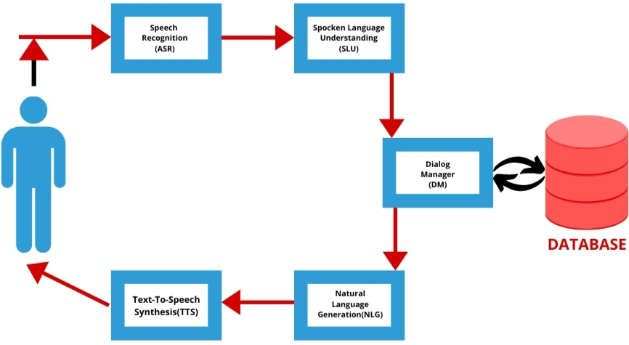

Figure 3. Dialogue System

**CONCLUSION :**

In this research paper we have discussed about some certain techniques to fabricate a Virtual Personal Assistant. Alongside with this, we've made a correlation for several Virtual personal Assistants. The primary goal of a Virtual Personal Assistant is to input speech or text hold and give results in speech or text, it also helps in managing data, it is intelligent and learns from the user. Our motive is to make student-friendly application in order to make the user work more quickly, comfortably and reliably.

The design of the Virtual Personal Assistant is the combination of datasets and some popular Machine Learning algorithms. It uses NLU to bring interaction between the user and the peripheral. Student can ask the Assistant to perform tasks according to his/her needs. It will also give regulative reminders as per as the order of student.

It'll reduce the stress in student for time and study management. Alongside improving service, it'll additionally reduce the human burden in the current pandemic situation and will surely build the efficiency.

# References

[1] Lopatovska, Irene, et al. "Talk to me: Exploring user interactions with the Amazon Alexa." Journal of Librarianship and Information Science 51.4 (2019): 984-997.

[2] Lopatovska, I., Rink, K., Knight, I., Raines, K., Cosenza, K., Williams, H., Sorsche, P., Hirsch, D., Li, Q. and Martinez, A., 2019. Talk to me: Exploring user interactions with the Amazon Alexa. Journal of Librarianship and Information Science, 51(4), pp.984-997.

[3] Kalns, Edgar T., et al. "Rapid development of virtual personal assistant applications." U.S. Patent No. 9,081,411. 14 Jul. 2015.

[4] DeLeeuw, William C. "Natural human-computer interaction for virtual personal assistant systems." U.S. Patent No. 9,607,612. 28 Mar. 2017.

[5] Yu, Dachuan, et al. "Telephone voice personal assistant." U.S. Patent Application No. 14/229,126.

[6] Kepuska, V. and Bohouta, G., 2018, January. Next-generation of virtual personal assistants (microsoftcortana, apple siri, amazon alexa and google home). In 2018 IEEE 8th Annual Computing and Communication Workshop and Conference (CCWC) (pp. 99-103). IEEE.

[7] Yadgar, O., Yorke-Smith, N., Peintner, B., Tur, G., Ayan, N.F., Wolverton, M.J., Acharya, G., Parimi, V.S., Mark, W.S., Wang, W. and Kathol, A., 2015. Generic virtual personal assistant platform. U.S. Patent 9,082,402.

[8] Yang, H. and Lee, H., 2019. Understanding user behavior of virtual personal assistant devices. Information Systems and e-Business Management, 17(1), pp.65-87.

[9] Tsiao, J.C.S., Chao, D.Y. and Tong, P.P., Mindfabric Holdings LLC, 2007. Natural-language voice-activated personal assistant. U.S. Patent 7,216,080.

[10] Wang, W., Vergyri, D. and Acharya, G., SRI International, 2019. Multi-lingual virtual personal assistant. U.S. Patent 10,402,501.